Clayton Weidinger

Senior Software Engineer, Team Lead, and Engineering Manager
clayweidinger.com linkedin.com/in/clayweidinger clay.weidinger@gmail.com 573-880-5609

Professional Experience
Software Engineering Roles, Carfax, July 2014—Present.
Development Manager of Software Engineering Development Program. Jul 2021—Present.
* Oversight of interviewing, hiring, onboarding, and initial evaluation of all Product Software Engineers. * Evolved interview team to triple candidate evaluations. * Interviewed, hired, and on-boarded 40+ engineers. * Served as People Manager for a handful of direct reports.

Senior Software Engineer, Team Lead of Platform Tooling/Engineering Team. Sept 2019—Jun 2021.
* Developed and maintained tools and APIs for cloud and legacy DevSecOps implementations across departments. * Automated Multi-region Multi-account Kubernetes deployments. * Migrated 2,000+ repos and CI/CD pipelines to GitLab. * Increased repo vulnerability scanning by 900+%.

Product Developer (Backend and Full Stack) for Banking and Insurance Group. Jul 2014—Aug 2019.
* Shipped 5 external product APIs. * Replatformed and extended CarfaxBig.com. * Led launch of CARFAXForClaims.com. * Evolved backend batch systems to improve reliability and scalability. * Product additions, scalability, and reliability contributed to the department's usage & revenue tripling over my tenure.

- High School Physics Teacher, Jefferson City, MO, May 2011—May 2014.
- * Taught Physics First curriculum to over 400 students. * Leveraged Assessment For Learning to tighten comprehension feedback loop. * Designed, developed, and launched iRemediate.com, an automated tutor service for students struggling to solve Physics word problems (decommissioned in 2014).

Registered Nurse, Surgical Intensive Care Unit, University of Missouri Health Care, Aug 2007—Aug 2010.
* Total Patient Care for two critically ill patients per twelve-hour shift. * Frequent substitute charge nurse shifts. * Preceptor/Trainer for 5 nurses.

Software Developer, The Lemberger Company, May 1998—Aug 2002 (~4,000 hours)
* Developed Accounting and Payroll Desktop Applications for K-12 Schools with VB6 and SQL.

Education
B.S. Physics, University of Missouri, Rolla, MO, May '06, GPA 4.0.
Minor in Computer Science and Mathematics
B.S. Nursing, University of Missouri, Columbia, MO, Aug '07, GPA 3.89.
M.S. Education, C&I, science, University of Missouri, Columbia, MO, Aug '09. GPA 3.78

Skills, Credentials, and Projects – clayweidinger.com
Languages Java, Groovy, SQL, Python, Kotlin, TypeScript, HTML, CSS, Terraform
Frameworks CDK, Grails, Spring, React, Angular, JQuery, Bootstrap
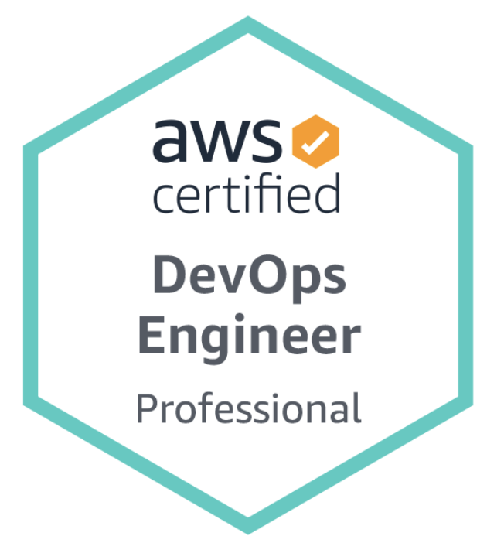
Software Git, Gradle, GitLab, RabbitMQ, MySQL, Oracle Database, Nginx
Testing JUnit, Spock, Selenium, Geb, Mockito

